#### SAVEETHA SCHOOL OF ENGINEERING

**SAVEETHA INSTITUTE OF MEDICAL AND TECHNICAL SCIENCES**

**CHENNAI-602105**

# RESTAURANT WEB APPLICATION

#### A CAPSTONE PROJECT REPORT

*Submitted in the partial fulfillment for the completion of the course*

**CSA4317 - INTERNET PROGRAMMING FOR MOBILE APP INTEGRETION**

**COMPUTER SCIENCE AND ENGINEERING**

**Submitted by**

**K. Someshwar Reddy (192210045)**

**B. Revanth Harsha Vardhan (192210076)**

#### Under the Supervision of

**Ms. L. Reetha**

**NOV 2024**

## DECLARATION

We, K. Someshwar and B. Revanth, students of Saveetha School of Engineering in Computer Science and Engineering, Chennai, hereby declare that the work presented in this Capstone Project Work entitled **Restaurant Website** is the outcome of our own Bonafide work and is correct to the best of our knowledge and this work has been undertaken taking care of Engineering Ethics.

Date:

Place:

## CERTIFICATE

This is to certify that the project entitled **“Restaurant Website”** submitted by

K. Someshwar and B. Revanth has been carried out under my supervision. The

project has been submitted as per the requirements in the current semester.

**Supervisor**

Ms. L. Reetha

# Table of Contents

|  |  |  |
| --- | --- | --- |
| **S.NO** | **TOPICS** | **PAGE NO.** |
| 1 | **Abstract** | 5 |
| 2 | **Introduction** | 6 |
| 3 | **Project Description** | 7 |
| 4 | **Problem Description** | 8 |
| 5 | **Tool Description** | 9 |
| 6 | **Block Diagram** | 10 |
| 7 | **Operations** | 11 |
| 8 | **Implementation** | 12 |
| 9 | **Result** | 18 |
| 10 | **Conclusion & References** | 20-21 |

## ABSTRACT

In the modern era, restaurant web applications have revolutionized dining experiences, offering a seamless blend of technology and culinary service. These applications enable users to browse menus, make reservations, and place online orders from the comfort of their homes. By integrating advanced features like real-time table availability, digital payment options, and user reviews, these platforms enhance customer convenience and satisfaction. They cater to diverse needs, from casual diners to food enthusiasts seeking personalized recommendations. Additionally, they act as a marketing tool for restaurants, showcasing offers and promotions to attract a broader audience. This dynamic approach bridges the gap between traditional dining and modern expectations.

The architecture of a restaurant web application typically consists of user-friendly interfaces, secure databases, and robust backend support. Frontend features focus on intuitive navigation, high-quality visuals, and responsive design to ensure accessibility across devices. The backend processes manage data efficiently, handling reservations, inventory, and customer orders in real-time. Integration with third-party APIs for payment gateways and delivery services adds flexibility and reliability to the system. This combination ensures a smooth user experience while maintaining data security. Employing technologies like cloud storage and analytics tools, these applications optimize operations, aiding restaurant management in making data-driven decisions.

Restaurant web applications benefit stakeholders by fostering stronger customer relationships and streamlining business operations. Customers enjoy a more personalized experience, with features like saved preferences, loyalty programs, and push notifications for updates and offers. Meanwhile, restaurant owners leverage insights from user behavior to refine menus and marketing strategies. In a competitive market, these platforms provide a strategic edge, allowing businesses to adapt to changing consumer demands swiftly. The future of restaurant web applications lies in leveraging emerging technologies like AI for smart recommendations and blockchain for secure transactions, ensuring they remain pivotal in the evolving food service industry.

## INTRODUCTION

The advent of restaurant web applications marks a significant milestone in the digital transformation of the food service industry. These applications serve as a bridge between technology and dining, addressing the growing need for convenience and efficiency in a fast-paced world. Customers can now explore menus, reserve tables, and place orders without stepping out of their homes. The shift to digital platforms has also opened new opportunities for restaurants to reach wider audiences, enhance customer engagement, and streamline operations. By blending innovation with hospitality, these applications redefine how people connect with food and dining experiences.

At the core of restaurant web applications lies the aim to enhance customer satisfaction and operational efficiency. These platforms are equipped with features like real-time table booking, interactive menu displays, and online payment options, which simplify the dining process for users. They also enable restaurants to collect valuable data on customer preferences and behavior, offering insights that help refine services. Furthermore, integration with delivery services and marketing tools ensures a holistic approach to customer engagement. The flexibility and scalability of these systems make them a valuable asset for businesses of all sizes, from local eateries to global chains.

In today’s competitive market, a restaurant web application is not just a convenience but a necessity. Consumers expect speed, customization, and accessibility, all of which are provided by these platforms. They also foster transparency, as features like user reviews and ratings empower customers to make informed decisions. For restaurants, these applications offer a cost-effective way to manage operations and improve brand visibility. As technology evolves, incorporating innovations like artificial intelligence and augmented reality will further enhance the functionality of these platforms, ensuring they remain integral to the dining experience of the future.

## PROJECT DESCRIPTION

This project involves the design and development of a full-stack web application for a food delivery service using the MERN stack—MongoDB, Express.js, React, and Node.js. The website offers an interactive and efficient platform for customers to browse and order food from a range of restaurants, providing a comprehensive digital solution that addresses the needs of both users and restaurant partners.

#### Key Features and Functionalities:

1. **User Authentication and Profile Management:**

Customers can create accounts, log in securely, and manage their profiles. User authentication is managed through a secure system, ensuring data protection and privacy.

#### Ordering and Checkout System:

Customers can browse restaurants, view menus, and add items to their carts. The checkout process is streamlined, with payment options integrated for seamless transactions.

#### Real-time Order Tracking:

Once an order is placed, customers can track its status in real-time. This feature provides transparency and enhances the user experience by allowing customers to monitor each stage of the delivery process.

#### Admin Dashboard:

The platform includes an administrative interface for managing users, restaurants, and orders. This dashboard enables streamlined monitoring and control over the system, allowing administrators to oversee operations efficiently.

## PROBLEM DESCRIPTION

The traditional dining experience often presents challenges for both customers and restaurant owners, creating inefficiencies that can hinder satisfaction and growth. Customers frequently face difficulties such as long waiting times for tables, limited visibility of menu options, and inconvenient reservation or ordering processes. On the other hand, restaurant owners struggle with managing peak-hour crowds, handling reservations manually, and keeping track of inventory and customer preferences. These issues lead to operational bottlenecks, reduced customer retention, and lost revenue opportunities. The absence of a streamlined solution also limits a restaurant's ability to cater to tech-savvy customers who demand quick and efficient services.

With the rise of digital technology, the gap between consumer expectations and traditional dining setups has become more pronounced. Restaurants without a digital presence risk falling behind competitors who offer advanced solutions like online ordering, real-time table booking, and personalized customer experiences. Additionally, poor communication channels often leave customers unaware of promotions or new menu items, impacting sales. Manual processes also make it challenging to analyse customer behaviour or adapt to changing trends. These inefficiencies highlight the urgent need for a comprehensive web application that addresses these problems, enhancing customer convenience while improving operational efficiency for restaurant businesses.

### TOOLS DESCRIPTION

**Frontend tools** like HTML, CSS, and JavaScript are essential for building intuitive and visually appealing user interfaces. Frameworks such as React or Angular enhance responsiveness and interactivity, ensuring seamless navigation across devices. For styling, tools like Bootstrap or Tailwind CSS streamline the design process, enabling the creation of modern, consistent layouts that enhance user engagement.

**Backend tools** form the backbone of the application, handling data processing and server operations. Technologies such as Node.js, Django, or Ruby on Rails are commonly used to build robust, scalable backend systems. These frameworks support functionalities like real-time order processing, inventory management, and user authentication. Databases such as MySQL, PostgreSQL, or MongoDB store and manage data securely, ensuring quick retrieval for smooth user experiences. Additionally, API integration tools like RESTful APIs or GraphQL connect third-party services such as payment gateways and delivery platforms, adding flexibility and functionality.

**Auxiliary tools** play a vital role in enhancing the application’s performance and usability. Cloud platforms like AWS or Google Cloud are utilized for hosting, offering scalability and reliability. Analytics tools such as Google Analytics or Mix panel provide insights into user behaviours, helping restaurants tailor their services to customer preferences. Security tools like SSL certificates and firewalls ensure the safety of sensitive user data, such as payment details. Lastly, version control systems like GitHub facilitate team collaboration during development, while CI/CD pipelines ensure smooth deployment and updates, making the application reliable and future-ready.

## BLOCK DIAGRAM

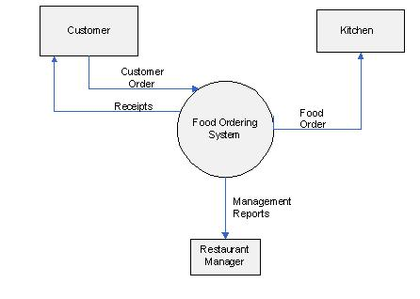

### OPERATIONS

In this food delivery website, various essential operations are implemented to manage users, restaurants, and orders. Below are the main operations and data storage requirements for the system:

#### Store Customer Information:

**First Name and Last Name:** Each customer's name is stored to personalize the user experience and for identification.

**Unique User ID:** Every customer is assigned a unique identifier for secure login and transaction tracking.

**Contact Details:** Includes email, phone number, and address for communication and order delivery.

#### Store Restaurant Information:

**Restaurant Name:** The name of each restaurant is stored to display it to users. **Unique Restaurant ID:** Each restaurant is assigned a unique ID for easy management and order tracking.

**Location and Contact Information:** Stores the address, contact number, and email of the restaurant for delivery and support.

**Menu Details:** Stores information about each item on the menu, including item name, description, price, and availability status.

#### Store Order Information:

**Order ID:** Each order is assigned a unique ID for tracking and management. **Customer ID:** Links each order to a customer, allowing for personalized order history and tracking.

**Restaurant ID:** Links each order to a specific restaurant, enabling efficient order routing.

## IMPLEMENTATION

#### Login Page(login.html):

<!DOCTYPE html>

<html lang="en">

<head>

<meta charset="UTF-8">

<meta name="viewport" content="width=device-width, initial-scale=1.0">

<title>Sprint Loan App - Login</title>

<style>

* {

margin: 0;

padding: 0;

box-sizing: border-box;

font-family: 'Arial', sans-serif;

}

body {

background: url('https://img.freepik.com/premium-photo/large-modern-restaurant-outside-view-with-trees-sky-generative-ai_634358-1000.jpg') no-repeat center center fixed;

background-size: cover;

display: flex;

justify-content: center;

align-items: center;

height: 100vh;

position: relative;

}

body::before {

content: '';

position: absolute;

top: 0;

left: 0;

width: 100%;

height: 100%;

background: rgba(0, 0, 0, 0.6); /* Adds a dark overlay */

backdrop-filter: blur(8px); /* Blur effect */

z-index: -1; /* Send the overlay behind the content */

}

.container {

width: 100%;

max-width: 400px;

background-color: #ffffff;

box-shadow: 0px 10px 25px rgba(0, 0, 0, 0.1);

border-radius: 15px;

padding: 40px;

}

.header {

text-align: center;

margin-bottom: 40px;

}

.header h1 {

color: #3498db;

font-size: 36px;

margin-bottom: 10px;

}

.header p {

color: #7f8c8d;

font-size: 16px;

}

.form-group {

margin-bottom: 20px;

}

.form-group label {

display: block;

color: #2c3e50;

font-size: 14px;

margin-bottom: 5px;

}

.form-group input {

width: 100%;

padding: 10px;

border-radius: 8px;

border: 1px solid #bdc3c7;

font-size: 16px;

}

.form-group input:focus {

border-color: #3498db;

outline: none;

}

.form-group .forgot {

text-align: right;

display: block;

margin-top: 5px;

}

.form-group .forgot a {

text-decoration: none;

color: #3498db;

font-size: 12px;

}

.btn {

width: 100%;

padding: 12px;

background-color: #3498db;

color: white;

border: none;

border-radius: 8px;

font-size: 16px;

cursor: pointer;

transition: 0.3s;

}

.btn:hover {

background-color: #2980b9;

}

.social-login {

text-align: center;

margin-top: 20px;

}

.social-login a {

display: inline-block;

margin: 0 10px;

text-decoration: none;

color: #3498db;

font-size: 16px;

}

.signup-link {

text-align: center;

margin-top: 20px;

}

.signup-link a {

text-decoration: none;

color: #3498db;

font-weight: bold;

}

</style>

</head>

<body>

<div class="container">

<div class="header">

<h1>SR's Kitchens</h1>

<p>Your trusted partner</p>

</div>

<form action="frontend.php" method="POST">

<div class="form-group">

<label for="username">Username or Email</label>

<input type="text" id="username" name="username" required>

</div>

<div class="form-group">

<label for="password">Password</label>

<input type="password" id="password" name="password" required>

<span class="forgot"><a href="#">Forgot password?</a></span>

</div>

<button type="submit" class="btn">Login</button>

</form>

<div class="social-login">

<p>Or login with:</p>

<a href="#">Google</a>

<a href="#">Facebook</a>

</div>

<div class="signup-link">

<p>Don't have an account? <a href="#">Sign up</a></p>

</div>

</div>

</body>

</html>

#### Home Page(dashboard.html):

<!DOCTYPE html>

<html lang="en">

<head>

    <meta charset="UTF-8">

    <meta name="viewport" content="width=device-width, initial-scale=1.0">

    <title>Welcome to SR's Kitchens</title>

    <style>

        @font-face {

            font-family: 'Blackadder ITC';

            src: local('Blackadder ITC'), fallback: serif; /* Blackadder ITC or fallback */

        }

        body {

            font-family: Arial, sans-serif;

            margin: 0;

            padding: 0;

            background: url('https://img.staticmb.com/mbcontent/images/crop/uploads/2024/6/vastu-tips-for-restaurant%20(1)_0_1200.jpg') no-repeat center center fixed;

            background-size: cover;

            color: #fff;

            text-shadow: 1px 1px 2px rgba(0, 0, 0, 0.8);

            display: flex;

            justify-content: center;

            align-items: center;

            height: 100vh;

        }

        body::before {

            content: '';

            position: fixed;

            top: 0;

            left: 0;

            width: 100%;

            height: 100%;

            background: rgba(0, 0, 0, 0.5);

            backdrop-filter: blur(0px);

            z-index: -1;

        }

        .container {

            text-align: center;

        }

        .container h2 {

            font-family: 'Blackadder ITC', cursive;

            font-weight: bold;

            margin: 0;

            font-size: 4em;

        }

        .container p {

            margin-top: 10px;

            font-size: 1.2em;

        }

        .button {

            display: inline-block;

            padding: 15px 30px;

            margin-top: 30px;

            font-size: 18px;

            color: white;

            background-color: #007bff;

            border: none;

            border-radius: 5px;

            text-decoration: none;

            cursor: pointer;

        }

        .button:hover {

            background-color: #0056b3;

        }

    </style>

</head>

<body>

    <div class="container">

        <h2>Welcome to SR's Kitchens</h2>

        <p>Explore our delicious food items!</p>

        <a href="items.html" class="button">Order Now</a>

    </div>

</body>

</html>

**RESULTS**

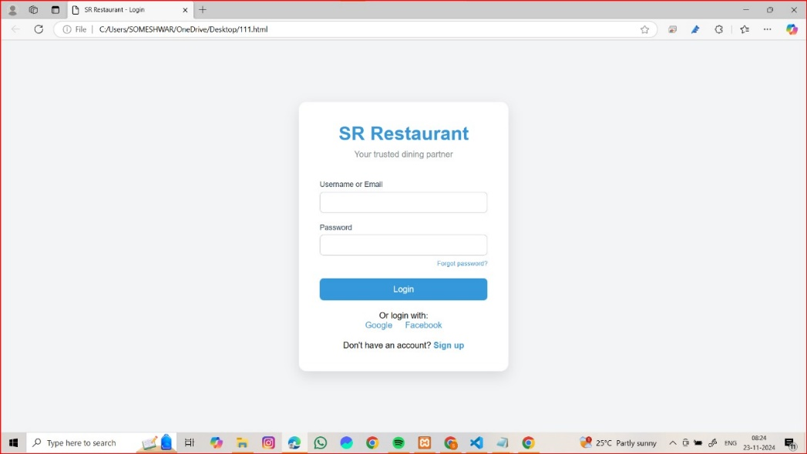

**Figure 1: Admin page**

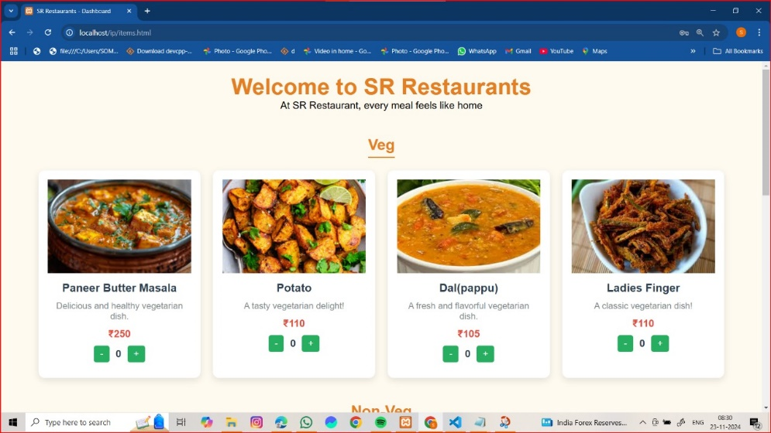**Figure 2: Home page**

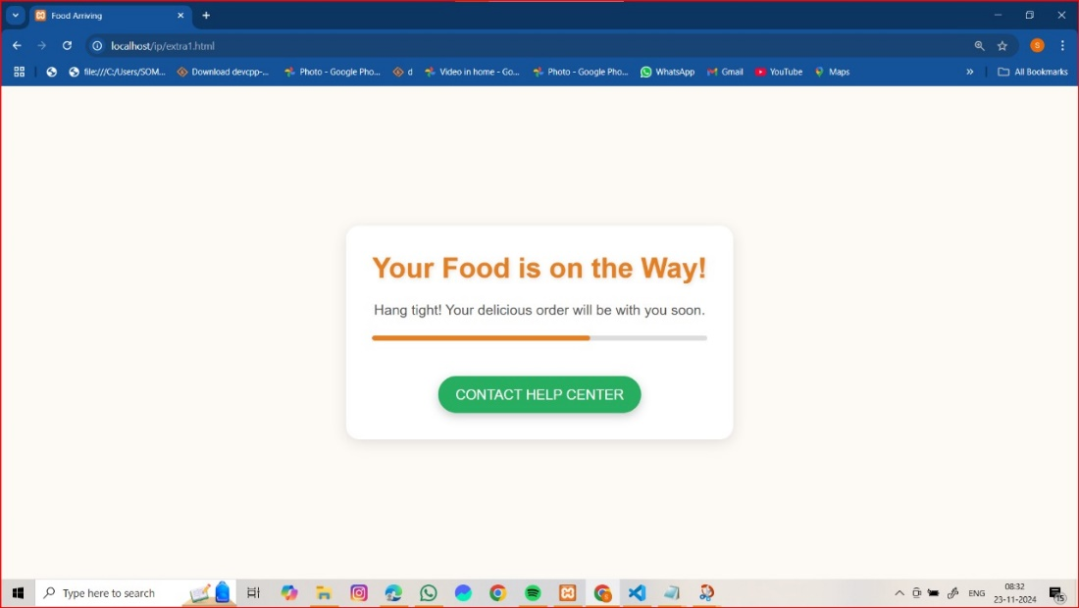

**Figure 3: Order Confirmation Page**

## CONCLUSION

Restaurant web applications have emerged as a vital solution to bridge the gap between traditional dining practices and modern consumer expectations. By offering features like real-time reservations, online ordering, and personalized experiences, these platforms enhance customer satisfaction and streamline restaurant operations. They empower businesses to optimize resources, reach wider audiences, and stay competitive in an evolving market. The integration of advanced technologies such as AI and analytics further ensures their relevance and adaptability. These applications are not just tools but transformative solutions shaping the future of the food service industry.

As dining habits continue to evolve, restaurant web applications will play an even more pivotal role in redefining customer experiences. They foster a seamless connection between technology and hospitality, enabling restaurants to deliver convenience, transparency, and efficiency. For customers, these platforms simplify the process of discovering, booking, and enjoying meals. For restaurant owners, they offer invaluable insights and opportunities to enhance service quality. Ultimately, investing in and continuously improving such applications ensures long-term success and a competitive edge in a dynamic and demanding industry.

### REFERENCES

### Building Modern Web Applications with React and Node.js" by John Smilga.

### Designing Interfaces: Patterns for Effective Interaction Design" by Jenifer Tidwell,

### Charles Brewer, and Aynne Valencia.

### Web Development with Node and Express" by Ethan Brown.

### E-commerce Trends in the Food and Beverage Industry" – Research by Statista.

### The Role of Technology in the Food Industry: A Case Study of Digital

### Transformation in Restaurants" by Journal of Hospitality and Tourism Technology.

### MongoDB: The Definitive Guide" by Kristina Chodorow.

### Payment Gateway Integration in Web Applications" by PayPal Developers

### Documentation.

### Web Application Security for Beginners" by John C. Greene.

### Cloud Computing for Web Applications" by AWS Whitepapers.

### The Future of Online Food Ordering Systems" by ResearchGate.